REPORT ON ICTMD
Study Groups on Music and Dance in Southeastern Europe & Ethnochoreology
Sub-Study Group on Music and Dance in the Black Sea Cultural Basin
Sub-Study Group on Field Research Theory and Methods
Joint Field Research in Türkiye and Georgia October 13 - 23. 2023,
by Mehmet Öcal ÖZBİLGİN & Izumi FAIRBANKS
Organizer: ICTMD TURKEY
Mehmet Öcal ÖZBİLGİN - National Organizer, ocal.ozbilgin@ege.edu.tr
Abdullah AKAT - Local Organizer, abdullahakat@istanbul.edu.tr
İdris Ersan KÜÇÜK - Secretary, idris.ersan.kucuk@ege.edu.tr
Participants:

Marko KÖBL (AUSTRIA)
Hamraz LOTFI (IRAN)
Izumi FAIRBANKS (JAPAN - USA)
Olga ROTARY (MOLDOVA)
Abdullah AKAT (TURKIYE)
Gökhan ALTINBAS (TURKIYE)
Resul BAGI (TURKIYE)
İdris Ersan KÜÇÜK (TURKIYE)
Özgün Arda NURAL (TURKIYE)
Tahsin ÖZASLAN (TURKIYE)
Mehmet Öcal ÖZBİLGİN (TURKIYE)
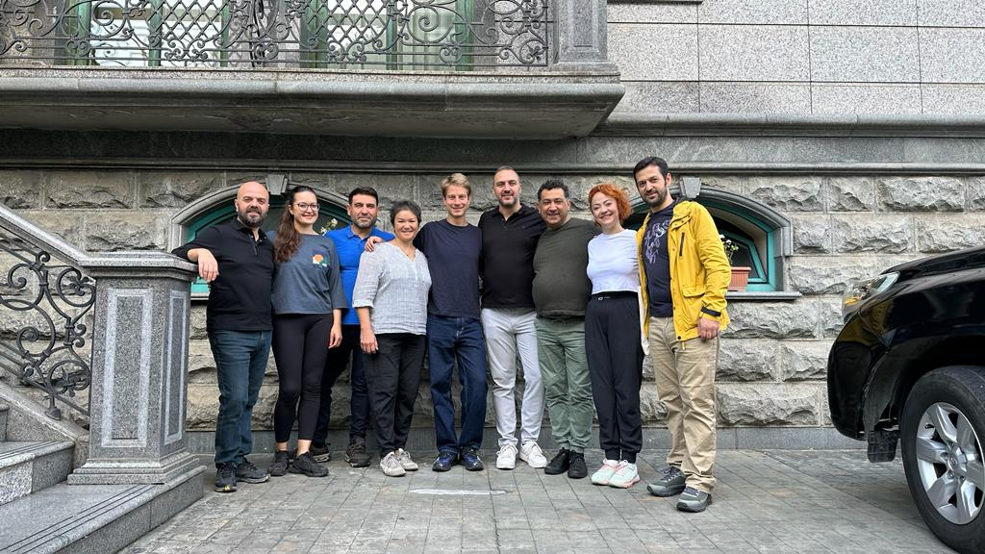

Scope for field research
The Black Sea cultural basin can be defined as an extensive area that geographically unites the Balkans, Crimea, Azov and Caspian Seas, Caucasus and Anatolia. Although there have been many ethnic and cultural layers and intersections across different regions of the Black Sea, there have been relatively few studies until today in the field of music and dance. Therefore, we decided to explore new studies with the idea of discovering different perspectives on the links from the past of the Black Sea cultural basin. 13 ethnomusicologists and ethnochoreolgists participated in this endeavor for us to re-think the music and dance in the Black Sea Cultural basin together.
The ICTMD Sub-Study Group on Music and Dance in the Black Sea Cultural Basin (of the Study Group on Music and Dance in Southeastern Europe) and Sub-Study Group on Field Research Theory and Methods (of the Study Group on Ethnochoreology), had fieldwork in Turkey and Georgia, on the occasion of some local municipalities’ financial supports. The Eastern Black Sea region comprises a natural environment with dance and music traditions. Additionally, educational foundations have an important role in the survival of dance and music traditions; because of the time of year (autumn being off-season), some of the research with local musicians and dancers in educational foundations was conducted in an artificial environment.
The research had three main themes with two different purposes: the ethnography of local peoples in the Eastern Black Sea region; and the study and documentation of village music/dance repertoire.
The first theme offered the possibility of experimenting with (new) modalities for collecting relevant information and eliciting the local people’s knowledge about their tradition to construct a visual text (film, photos) that may ‘translate’ the transient reality as closely and illustratively as possible.
The second theme was the study of ethnic communities that retain their own culture as they adapt to urban life.
The third theme was to study and record the dance transmission - the reception process (from local people to foreigners), and to experiment with recording and ‘on the spot’ dance analysis in the fieldwork context.
Field research was conducted in 2 countries, 5 cities (Trabzon, Giresun, Rize, Artvin, Batumi), 10 towns (Görele, Tonya, Sürmene, Maçka, Pazar, Çamlihemşin, Fındıklı, Borçka, Kemalpaşa, Sarp) and 14 villages. Interviews were held with 39 dance resource persons, 34 music resource persons and 5 instrument makers about local dances and music. More than 20 dances with different variations were compiled and recorded from approximately 100 dancers. Monophonic and polyphonic traditional songs were compiled from resource persons. Interviews were held about the production and playing techniques of drums, zurna, kaval, accordion, kemençe and tulum instruments. Dance music, entertainment music, laments, etc. in the form of live music and singing, in different local environments, was recorded.
​
Research Schedule and Research Areas
Friday, October 13: Trabzon City - Akçaabat Town
Akcaabat Town
Researching in Akcaabat Folklore Association: museum visit with association director Ahmet Cilingir, and interviews with Cavit Senturk (b. 1941, Akçaabat), horon master and former instructor of Turkish Folk dance department and writer of “Ruzgar Topuklu Adam”, davul player Sinan Guneysu (b. 1981, Akçaabat), kemence player Hasan Seyis (b. 1960, Akçaabat), zurna player Omer Gaydan (b. 1953, Akçaabat), zurna player Ibrahim Karaagac (b. 1995, Akçaabat). Girls’ ensemble, boys’ ensemble performances, demonstrations, interviews, Q&A, etc.
Ortamahalle Museum (St. Michael’s Church) visit.

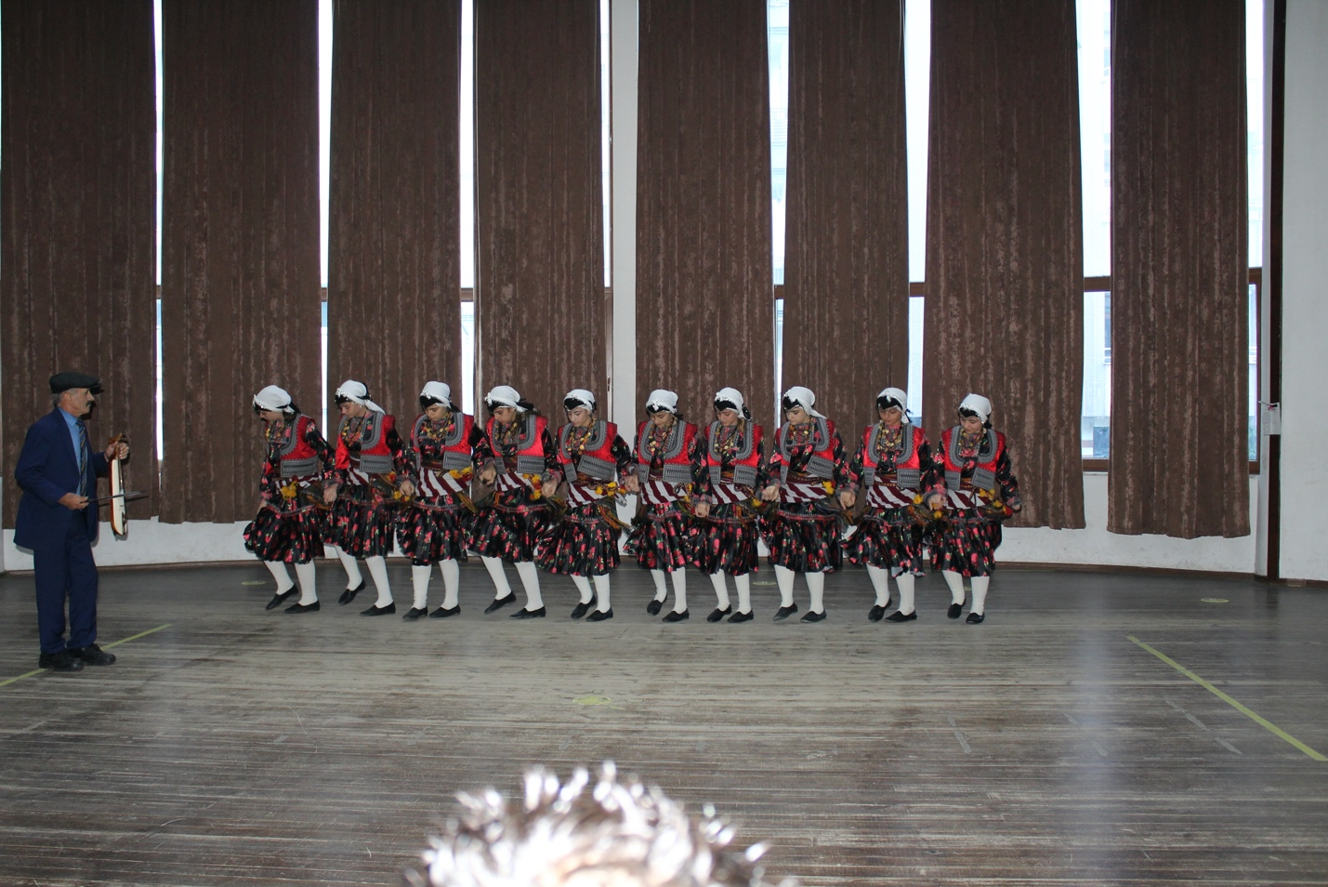

Saturday, October 14: Trabzon and Giresun Cities - Görele & Tonya Towns
Görele Town
Visiting Görele Kemençe Museum.
Meeting with folklorist Hayrettin Günay (davul player, b. 1954, Görele), telling us about horan and his works.
Horan ensemble from Görele demonstrating dances with kemençe player Hasim Torun (b. 1982, Görele).
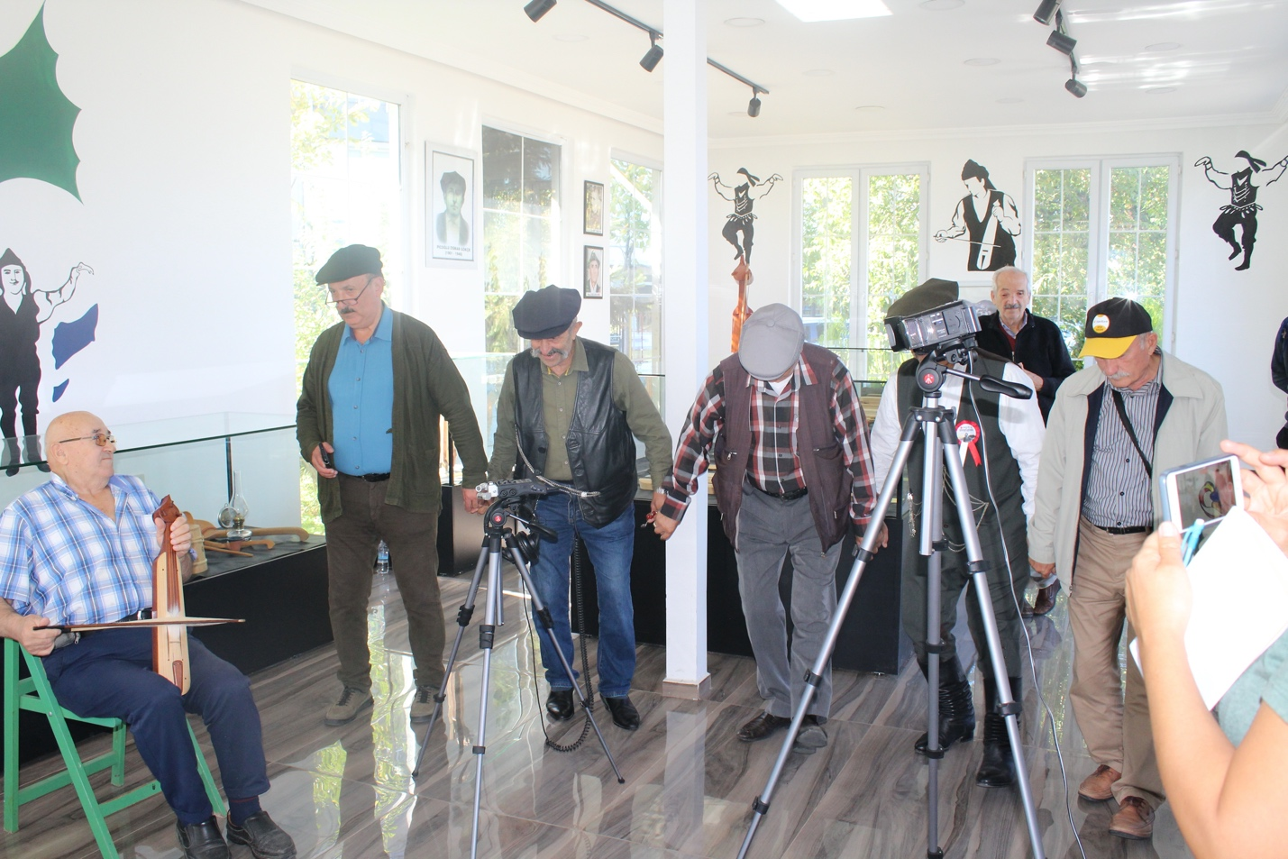

Dancers:
Kazım Maksutoğlu (b. 1950, Görele)
Mehmet Menteşe (b. 1953, Görele)
Kemal Kepçeoğlu (b. 1957, Görele)
Ahmet Torun (b. 1957, Görele)
Mehmet Çolakoğlu (b. 1954, Görele)
Burhan Caba (b. 1953, Görele)
Talk about Görele style and demonstration for songs and horan by kemence player Burhan Caba (b. 1953, Görele).

Recording of dance and music of Görele horan ensemble:
- Cezayir
- Hamzabaş
- Siksara
- Kız horonu
- Gelin alma
- Kadın ince oyun
- Taksim

Tonya town - Kadiralak Yayla (highlands)
Field research with researcher Ugur Ulu (b. 1989, Trabzon).
Meeting members of [Tonya Men’s Folkloric Ensemble] at Tonya Trabzonspor Fan Association.
Visiting Kadiralak Yayla (highlands) with association director Mr. Mustafa Balci (b. xxxx, xxxx) to conduct interviews with Fatma Kalyoncu (singer, b. 1950, Tonya) and Mustafa Kalyoncu (b. 1949, Tonya). Recording of “ağıt” (lament) demonstration and interviews; sample of horon.

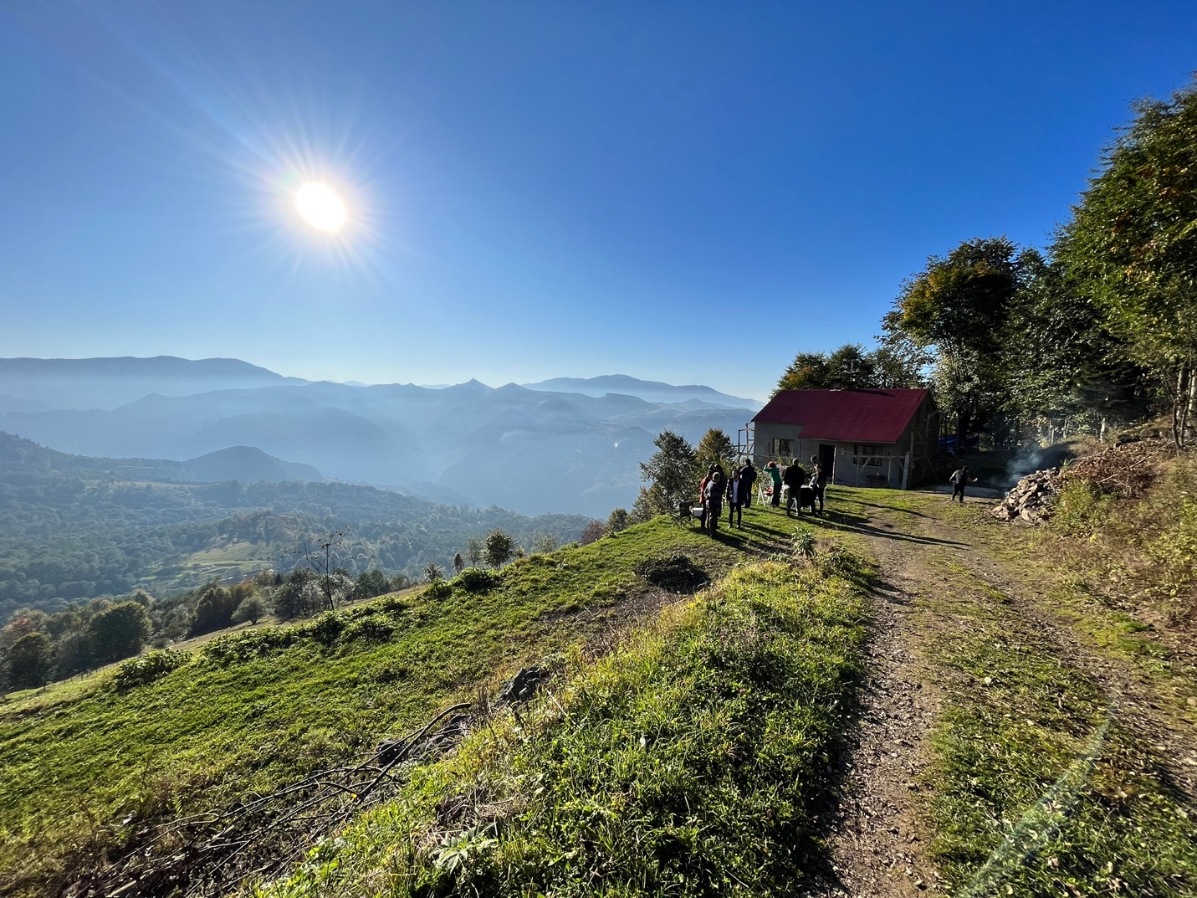

Tonya Town center
Dance demonstration outside, by the men’s ensemble.
Kemence player: Ayhan Oğuz (b. Tonya, 1986).
Dancers:
Mehmet Salih Bektaş (b. 1971, Tonya)
Murat Bayrak (b. 1958, Tonya)
Mustafa Aktaş (b. 1956, Tonya)
Mustafa Baki (b. 1974, Tonya)

Recording of dance and music of Tonya Men’s Folkloric Ensemble:
1- Tuzcuoğlu
2- Hasbal
3- Tik horon
- Doldurmalı
- Aşşağı alma
- Kandazoğlu
- Tonya Doldurması

Visiting the home of İlknur Zeynep Yakupoglu (b. 1968, Tonya), including brother Savas Yakupoglu (b. 1978, Tonya), mother Gülcan Yakupoglu (b. 1937, Tonya). Discussion on current state of local folklore and efforts to preserve it; demonstration of songs and ağıts (laments); discussion on women’s culture around music and dance (kemence, horon etc.).

İskenderli Village
Visit and interviews with Mustafa Ulu (b. 1965, Tonya) and Ayse Ozdemir (b. 1952, Tonya) - uncle and aunt of Ugur Ulu.
Dance demonstrations by Ugur, Mustafa and Ayse.

Recording of dance and music:
1- Kadın Horonu
2- Erkek Horonu
3- Yol havası
4- Oturma Gaydası

Sunday, October 15: Trabzon City - Sürmene & Maçka Town
Surmene Town
Visiting the Surmene Folkloric and Youth Association.
Meeting with Hasan Kurt, association director, Nizamettin Er, former folk dancer, and Okan Ismailoglu, assistant association director and folkdance trainer.
Interview with kaval and zurna player Omer Parlak (b. 1964, Sürmene); demonstrations of the 3 types of wind instruments kaval, zurna, kaba kaval (mi-do-la) and music for different areas of Surmene; dance demonstrations.
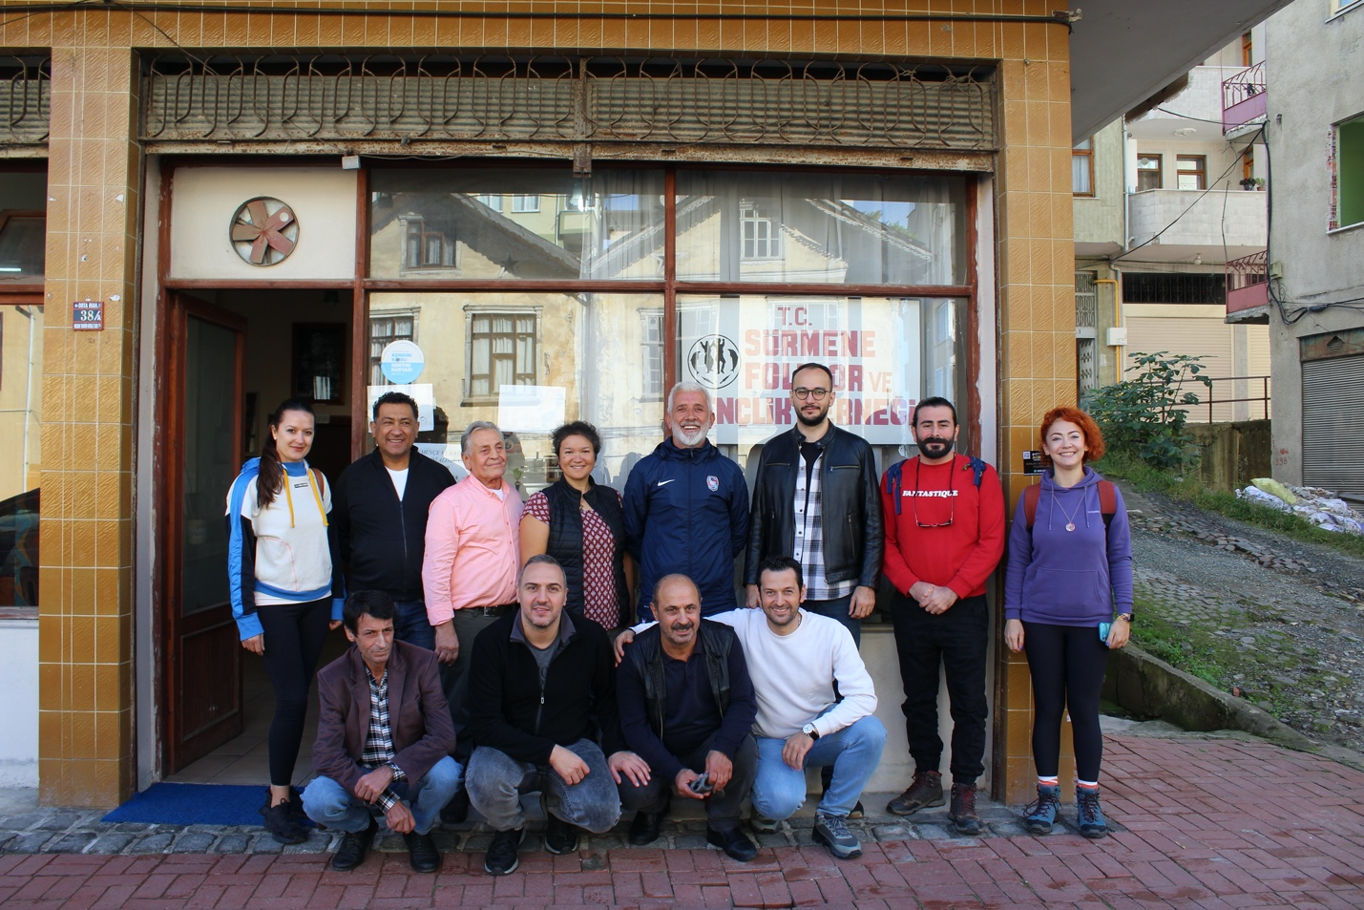
Dancers:
Hasan Kurt (b. 1956, Sürmene-Köprübaşı)
Nizamettin Er (b. 1945, Sürmene-Ortamahalle)
İlhan Parlak (b. 1976, Sürmene-Ormanseven)
Okan Ismailoglu (b. 1965, Sürmene)

Recording of dance and music:
- Aşşağı Batum
- Çamburnu sallaması
- Kaval horonları

Interview with kemence player Ilhan Parlak (b. 1976, Sürmene); demonstration of melody examples for Surmene melodies, with dance by above dancers.

Recording of music:
- Pabuçlarım delindi
- O kadar g(K)aramıyım
- Trabzondur yolumuz

Macka - Catak village
Visit with artist and kemence maker Eyup Eyupoglu (b. 1960, Macka Ocaklı village), at his home/workshop.
Interview with Eyupoğlu about the production process of the kemence instrument; examples of Macka melodies on kemence. Interview with Neriman Eyupoglu (Eyup Eyupoglu’s mother).
Table songs/muhabbet with singers/players Erol Dulger and Mustafa Aydin, singer and dancer from Sevinc village. Horon dance guided by Neriman. Dancing men’s horon variety with Eyup’s kemence.
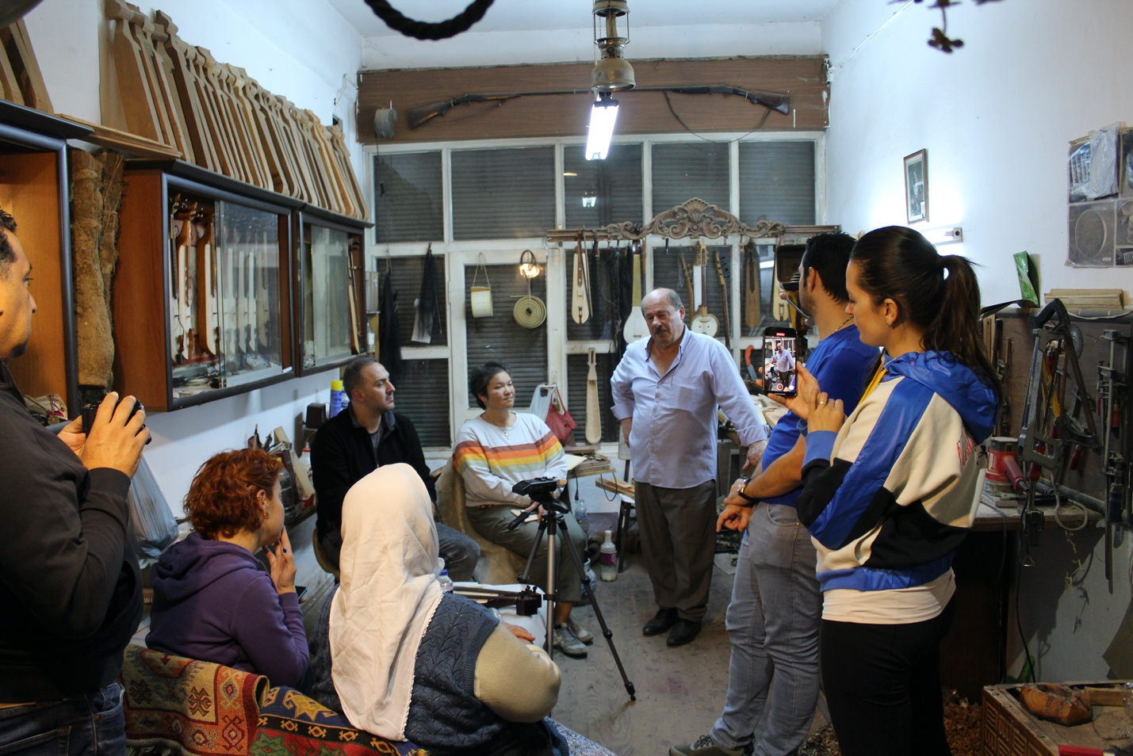

Monday, October 16: Rize City - Pazar & Camlihemsin Towns
Gundogdu village
Meeting with local armonik players at the Kotil family home.

Sezayi Meral (b. 1953, Rize-Gündoğdu)
Fikret Kotil (b. 1948, Rize-Gündoğdu)
Barış Bakır (b. 1975, Rize-Gündoğdu)
Ayla Kotil (b. 1953, Rize-Gündoğdu)
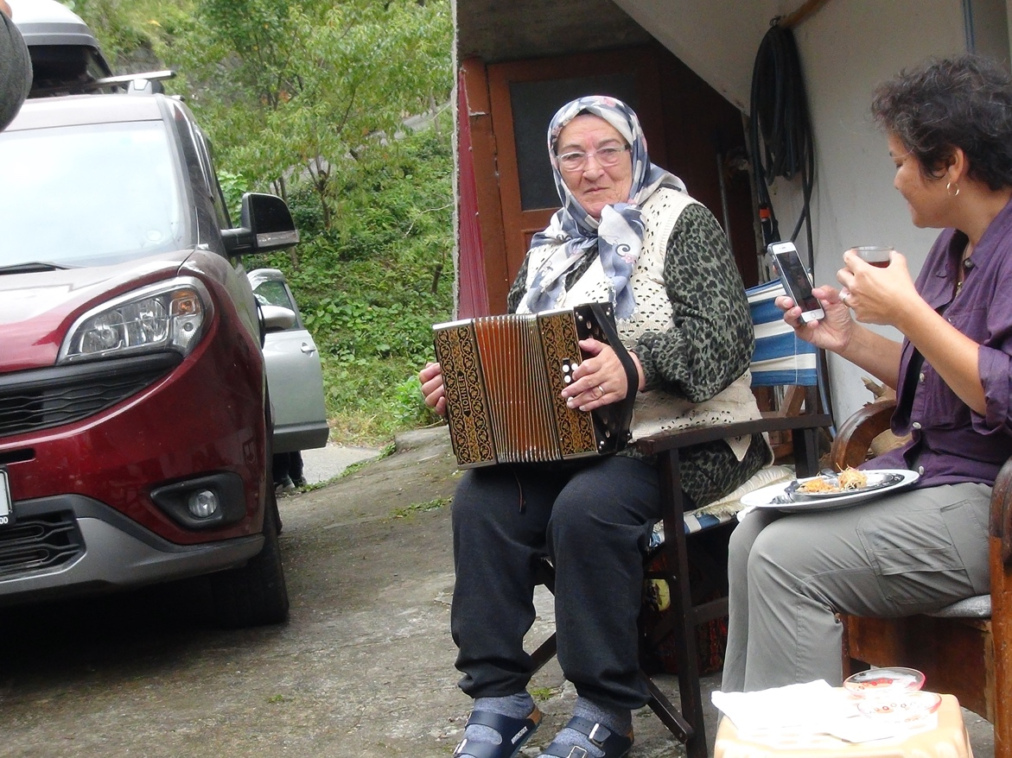

Interviews and demonstration of examples of common melodies; demonstrations of dances.

Recording of dance and music:
- Atlama
- Sıksara (Titreme horonu)
- Gelin havası
- G(h)umrik (Kız horon havası) (iki ayak)
- Kadı bağı (Türkü atma)

Pazar Town - Apso village
Meeting with destan singer Senol Topaloglu (b. 1963, Pazar) at his home.
Interview and demonstration of “destans” (ballads) he learned from his older brother and those of his own.

Camlihemsin Town
Meeting with Metin Gultan (b. 1959, Çamlıhemşin), former cultural association director in Camlihemsin.
Travel to the home of Huseyin Reyhan (b. 1963, Çamlıhemşin), tulum player, in Yukarı Çamlıca village.
Talk by Metin Gultan about local customs, culture, music, dance, as well as family life.
Demonstration of melodies, and dances.
Participatory horon in the kitchen with Reyhan’s son playing.

Komilo village
Tulum Sanat Atolyesi
Visiting Tulum maker and player, Engin Dervisoglu (b. 1991, Çamlıhemşin).
Interview with Engin about the tulum and its production; demonstration of a few common melodies.

Tuesday, October 17: Rize City - Pazar & Çamlıhemşin - Fındıklı Towns
Camlıhemşin Town, Dikkaya village
Traveling to Dikkaya village to meet with Suleyman Serin (b. 1964, Dikkaya), tulum maker, player, saz player.
Interview and demonstrations on tulum and saz in his workshop converted from a serender, an Eastern Black Sea style storage building.
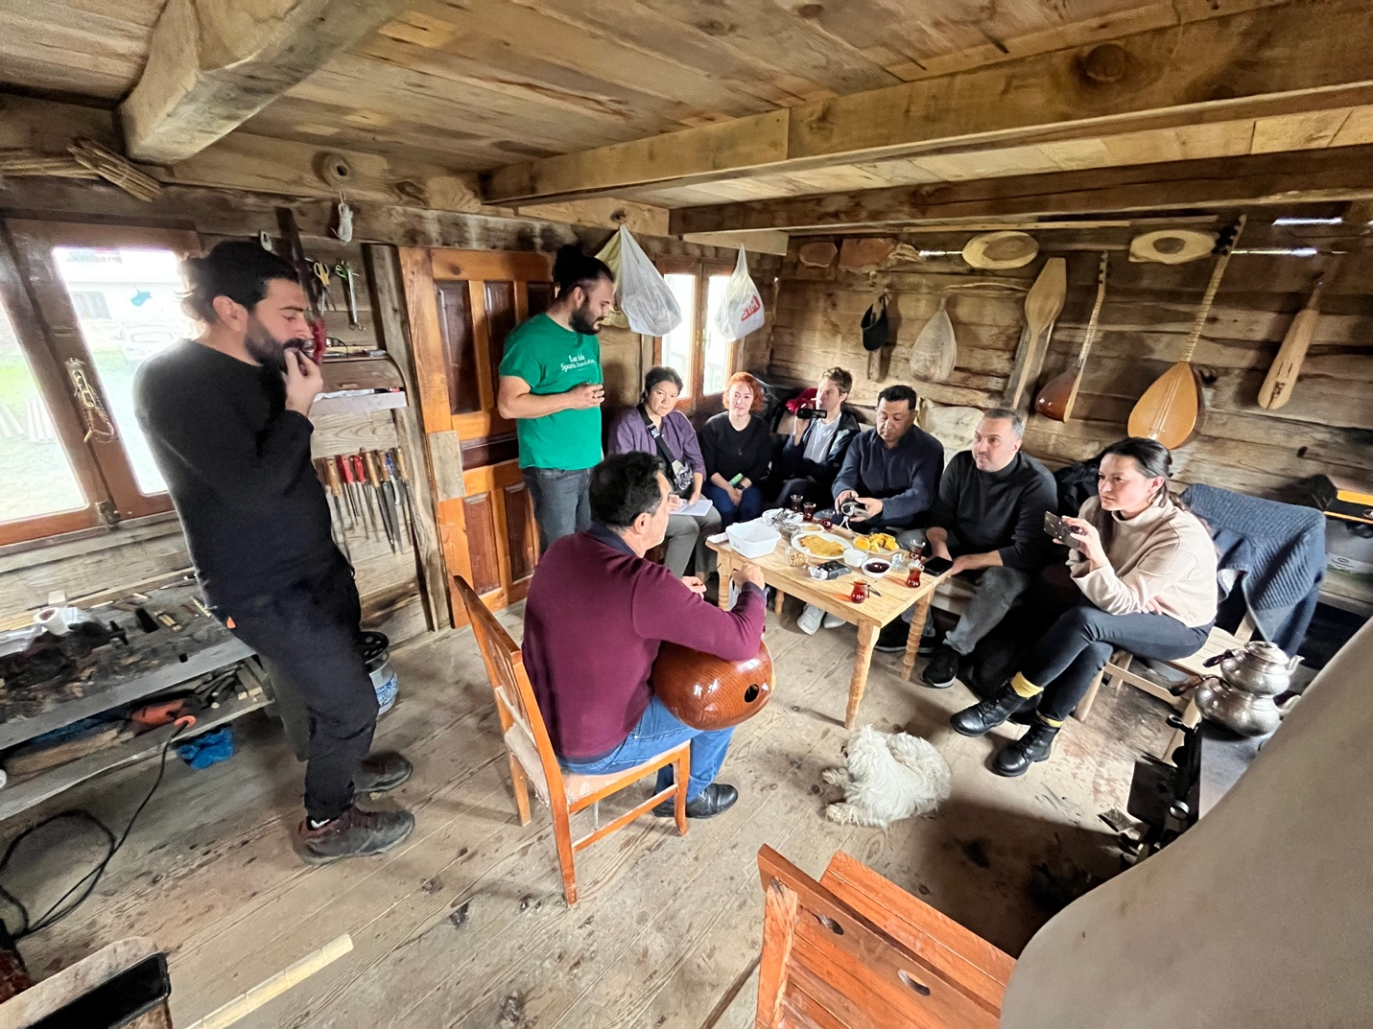

Pazar, Zafer village
Traveling to the village to meet with tulum maker Şükrü Parlak (b. 1953, Rize), who is also a hawk trainer. Interview about the tulum production process, the tradition of falconry, demonstration of common melodies.

Fındıklı Town
Visiting GOLA (local Laz Cultural Association).
Meeting with Cisem Sendeniz (GOLA staff), Ebru Demir (b. 1976, Giresun); a founder of the local Laz women’s choir) for discussion on Laz music and culture.
Also: elder singer, kemence player Yilmaz Sisman (b. 1953, Fındıklı), elder shepherd and tulum player Yetişen İnce (b. 1942, Fındıklı) played us some regional melodies; additional discussion with Caner Karatas (b. 1986, Fındıklı), on dances.

Wednesday, October 18: Artvin City - Borçka Town
Borcka Town
Meeting with mayor Ercan Orhan (b. 1970, Borçka) at the Borçka Municipality building. Discussing prospective initiatives and collaborative efforts to preserve the cultural heritage in terms of music and dance.

Borçka Solidarity Cooperative events:
Meeting with local musicians, singers and dancers.
Interview with Ibrahim Orhan (mayor’s father, b. 1935, Borçka), regarding Kars Cilavuz Teachers’ School and Deviskheli dance culture, and accordion demonstration.
Interview with accordionist Emrullah Keskinkurt (b. 1945, Borçka) about accordion; demonstrations.

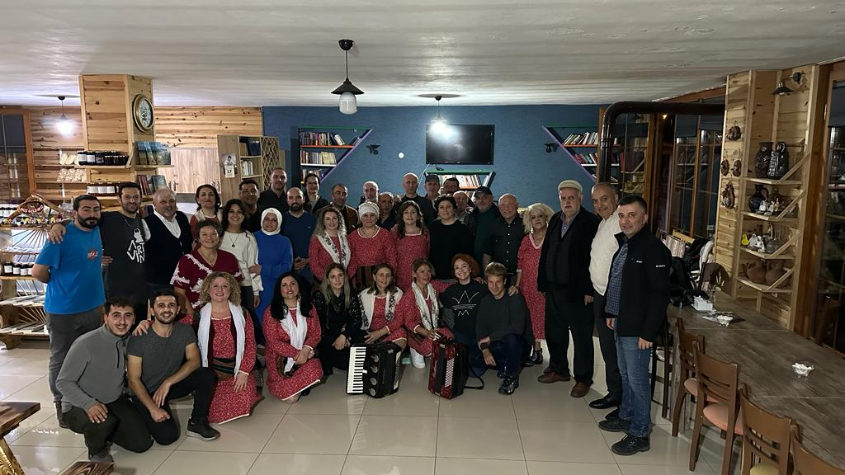

Interview with cooperative director Hasan Özışık (b. 1961 Borçka) and Borçka Municipality Women’s Choir. (founded in June 13, 2021).
Music performance by [musician Yasar Turan] and Hasan Özışık.
Recital (4 songs) by the women’s choir.
Arzu Keskinkurt Ulu (b. 1980)
Yüksel Akarsu Taban (b. 1962)
Dilek Korkmaz (b. 1979)
Dilek keskinkurt (b. 1988)
Fatma Küçük Atasert (b. 1977)
Ceylan Aral Özbaş (b. 1987)
Hülya Kırçiçek (b. 1986)
Nurcan Alpaydın (b. 1976)
Sevgi Keskinkurt Akyüz (b. 1984)
Elif Uzunal (b. 1984)

Accordion set by Hasan Özışık - dancing with “Kafkas Ruzgari” dance troupe.
Baglama and accordion set by mayor Ercan Orhan - dancing for all.

Recording of dance and music:
- Yol havası (Cezayir)
- Gelino (Gelin havası)
- Sarı çiçek
- Çift jandarma
- Atabarı
- Düzhoron
- Borçka hemşin
- Sarı çiçek
- 14 oyunu

Dancers:
Isa Atar (b. 1969, Borçka)
Alirıza Atar (b. 1976, Borçka)
Musatfa Şahin (b. 1965, Borçka)
Bedri Gökaydın (b. 1969, Borçka)
Ekrem Yılmaz (b. 1971, Borçka)
Necati Genç (b. 1966, Borçka)
Erhan Orhan (b. 1973, Borçka)

Thursday, October 19: Artvin City - Borçka Town and Center
Macahel Village
Driving to Macahel Camili and Efeler villages to meet with Macahel Polyphonic Choir members.
Meeting the head of Camili village (Mehmet Kurban) and Mr. Altan.
Arrival of singer Hamdi Erturk and driving to Efeler village to Muhittin and Hatice Gokdemir’s home.
Gathering of the choir for interviews. Demonstration of songs and some dances.
Singers and Dancers
Medeni Altun (b. 1962, Macahel)
Hamdi Ertürk (b. 1946, Macahel)
Cemal Karadeniz (b. 1948, Macahel)
Cavit Kahya (b. 1970, Macahel)
Muhittin Gökdemir (b. 1961, Macahel)
Hızır Gökdemir (b. 1965, Macahel)

Artvin Center
Meeting at Artvin Genclik Merkezi (Artvin Youth Center) to meet with local accordionists and dance troupe.
Interview with accordionist Sedat Algin (b. 1960, Artvin), and demonstration of music.
Interview with Metin Meriç (b. 1965, Artvin), older folkdance trainer.
Interview with Onur Dede and Ferhat Altuntas, younger folkdance trainers.
Dance demonstrations by the troupe with Sedat’s accordion accompaniment.

Dancers
Onur Dede
Emre Uygun (b. 2006)
Ebru Güney (b. 2005)
Enes Taner Gümüş (b. 2005)
Rümeysa Kırçiçek (b. 2005)
Eymen Işık (b. 2008)
Berfin Öztürk (b. 2007)
Sıla Altuntaş (b. 2004)
Deren Ela Çoruh (b. 2008)

Friday, October. 20: Artvin City - Kemalpasa Town / Batumi City, Georgia
Kemalpasa Town
Traveling to Kemalpasa to meet with dilli kaval players.

Meeting with Senol Celik [Kemalpasa provincial council member and environmentalist, organizing to go to village for private interviews and demonstrations. Talking with Avni Gumuskaya (elder kaval player) while waiting for the other local musicians of kaval and tulum.

Driving to village for music and dance (in order of dances) demonstrations with Aslan Akbiyik (tulum and kaval player), Kadir Yilmaz (kaval player), dances by Soner Celik and other individuals.

Sarp and Batumi
Traveling to Sarp for border crossing; arrival at Batumi Art Teaching University to attend the Opening ceremony of the 18th Giorgi Garaqanidze Church and Folk Music International Festival.
Opening ceremony and concert by local and visiting choirs.
Dinner with Teona Lomsadze and Sopiko Kotrikadze.

Saturday, October. 21: Batumi City, conference day 1
Scientific Conference, 10:00-15:00 (3rd Floor Hall, Batumi Art State University)
Session Chairs: Khatuna Managadze, Tamaz Gabisonia.
Speakers: Sopiko Kotrikadze, Tamaz Gabisonia, Izumi Fairbanks, Laura Kutubidze, Idris Ersan Kucuk, Teona Lomsadze, Vazha Zubashvili, Robert Rick, Marika Nadareishvili, Hamraz Lotfi Korul, Ketevan Baiashvili, Natalia Zumbadze, Maka Khardziani.

Choral concert at 19:00.
Performers: Arsiani, Sameba, Gogalai, Kolkha, Rekheuli, Kirialesa, Iagundi, Nanina, Sahara, Sakanela, Susan Thompson.

Sunday, October 22: Batumi City, conference day 2
Scientific Conference 10:00-15:00 (3rd Floor Hall, Batumi Art State University)
Session Chairs: Khatuna Managadze, Teona Lomsadze
Speakers: Abdullah Akat, Ekaterine Oniani, Mehmet Ocal Ozbilgin, Olga Rotari, Teona Benashvili, Marko Kolbl, Gokhan Altinbas, Tamar Chkheidze, Resul Bagi, Nun Nino Samkharadze, Ekaterine Kazarashvili.

Choral concert at 19:00.
Performers: Kolkha, Gogalai, Amer-Imeri members and Susan Thompson, Nanina, Iagundi, Kirialesa, Sameba

Monday, October 23: Batumi City
Visiting the Adjaran Song and Dance State Academic Ensemble “Arsiani” (organized by Prof. Kucuk for available team members), to meet with chief choreographer [Giorgi Chachava ] and ensemble director Giorgi Tchanishvili; observing the rehearsal by the dance ensemble.

